Sustainability & Social Investment Policy
Social Investment
Grasshoppers is based in Sandwell, one of the most deprived authorities in England.
Apart from the competitive aspect and improved physical health, we see netball as a vehicle to promote positive social relationships, creativity and positive mental health and wellbeing.
What we do already/have done:
Giving back – fundraising/charity events egs:
March 23 Comic Relief – Everyone wore red & donated £1 or what they could afford. Fun warm ups before usual training, Comic Relief dancing sweepstake. Donated £100:
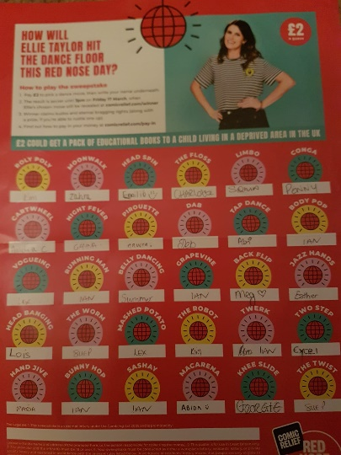

Dec 22 Christmas Family Fun session – entry fee food bank donation, fancy dress & prize:


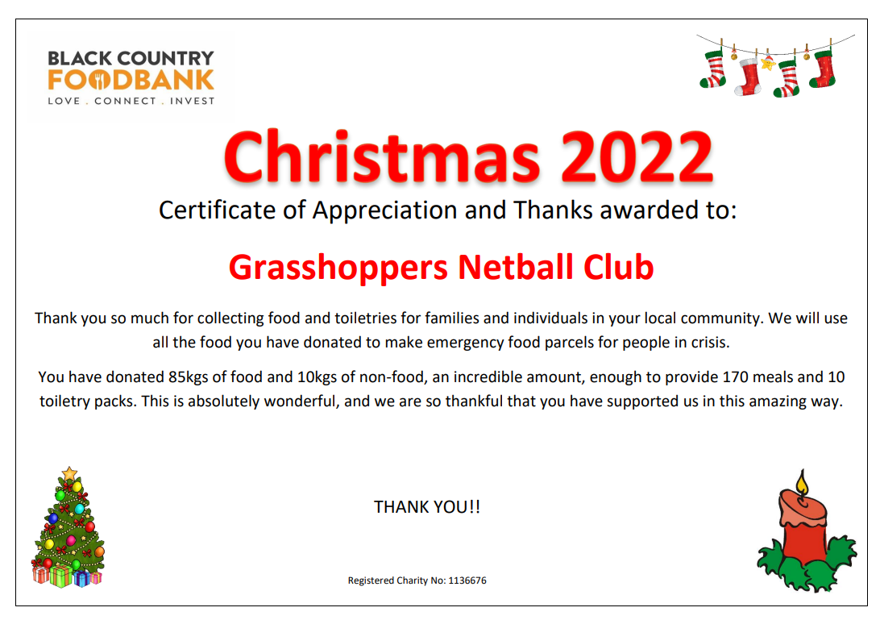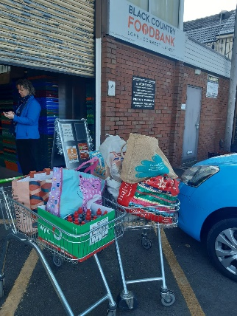
Dec 22 Birmingham City Mission toy donations – ours are in here somewhere!!
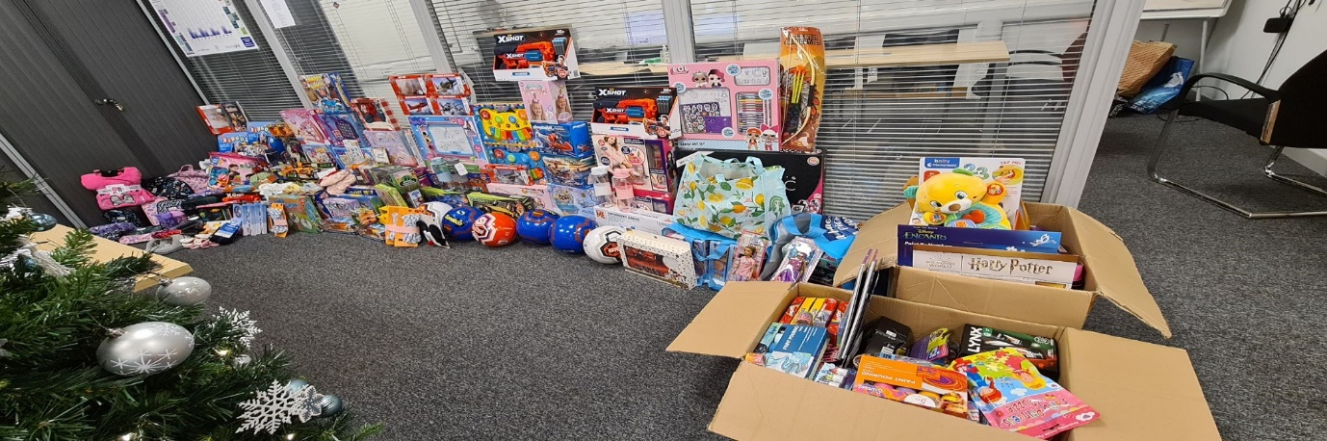
Nov 21 Kit donation to Africa (after Ghana experience) – Home | Netball Development Trust (netballtrust.co.uk) – all ‘old style’ kit donated
Mar 20 Sport Comic Relief – 100 shot challenge – raised over £200:

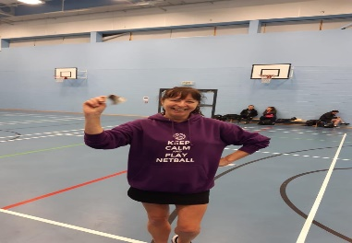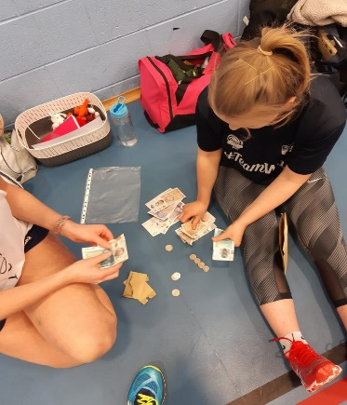
Mar 19 Head Coach Lex – Ghana trip – Netball Development Trust - 100 shot challenge – raised £575.50.
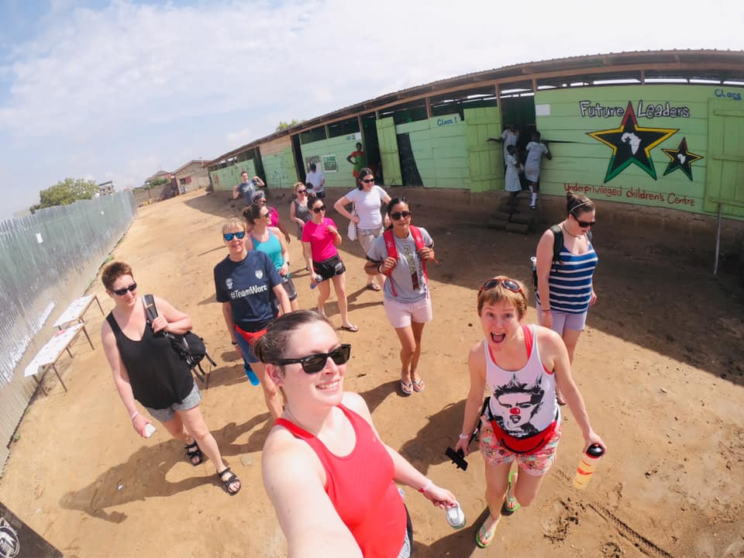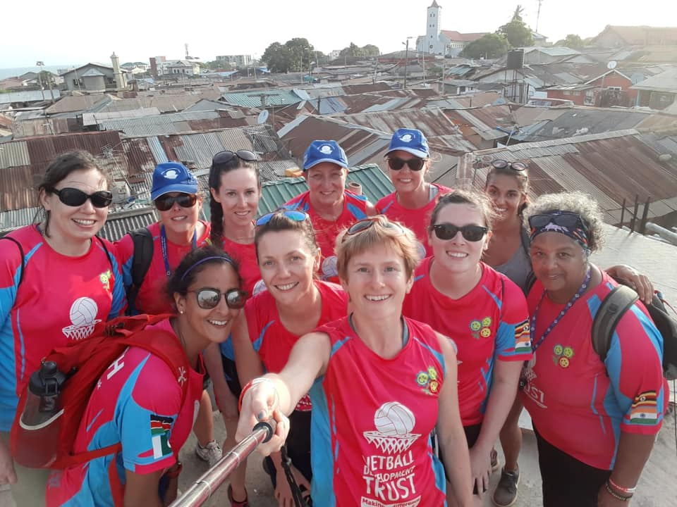


Feb 15 – Family Fun tournament raised £166.50 for Birmingham Children’s Hospital


Sustainability
Climate emergency
The government declared a climate emergency in 2019, setting a net-zero carbon target by 2050. We know sport and physical activity is essential to physical and mental wellbeing, and part of encouraging and enabling physical activity is about making positive choices – choosing to get around without using polluting vehicles, making neighbourhoods more easily negotiated on foot or by bike and connecting neighbourhoods to where we need to get to and from.
Please share a car journey with another player/Club member wherever possible
There’s a keen interest and awareness about environmental sustainability across the sector and a willingness to promote change where needed. Everyone understands there’s much more to be done, from the management of major events, sustainable travel policies and selection and use of recyclable materials, to the creation and operation of energy and resource-hungry facilities.
Please use only re-usable drinks bottles for training & matches – no single use plastic here please!
Sports organisations should continue to lead by example, take a critical look at how we operate, quantify and record consumption and waste, and set challenging targets to reduce or eliminate it. Responding to climate change is not an easy task but there’s no choice here. The sport and physical activity sector is a force for good and has a major contribution to make.
Every day we make choices in our lives that affect the environment, the climate and other species. From what we eat to how many children we decide to have, there’s a lot we can do to “choose wild” and reduce our environmental footprint to leave more room for wild animals and plants.
Think twice before shopping – do you really need a new XXXX?? Use charity & other second hand options, hire rather than buy.
Trainer donation – NDT, shoe bank, or similar?
Other clothes – H&M Close The Loop – see link: Let's close the loop | Repair & recycle | H&M (hm.com)
But if you DO need to shop & can do so online, use Easy Fundraising site please!
https://www.easyfundraising.org.uk/causes/grasshoppersunijetnetballclub/
Make sure your big purchases have big environmental benefits. eg A+++ rated appliances, wherever possible – see link: What you need to know about the new energy label - Energy Saving Trust
And if you’re going to buy & can do so online, use Easy Fundraising site please!
https://www.easyfundraising.org.uk/causes/grasshoppersunijetnetballclub/
Go #PlasticFree - use reusable bags when you shop; go for NO wrapping where possible eg fruit & veg; Ditch clingfilm - use beeswax wrappers, or foil instead – Sue P will take clean used foil off your hands for RNIB; Ditch single use water bottles; avoid products made from or packaged in plastic whenever possible

Pay attention to labels – take time to read eg, where the item comes from – shop locally wherever possible. From coffee to fruit to clothing, the number of options out there can get overwhelming — but there are some clear leaders when it comes to minimizing your impact on wildlife and the planet. If you’re a coffee drinker, look for “shade-grown” coffee, which is grown while keeping forest habitats intact for migratory birds and other species. Choose Fair Trade certified goods when possible to support companies dedicated to sustainable production and paying laborers a fair wage. Buy organic food whenever possible; it may cost a little more, but it keeps harmful pesticides out of our land and water, protecting farm workers, wildlife and your family.

Be water wise – don’t waste it!! Water conservation is critical, especially as our growing population puts increased demand on the nation’s water sources and we face unprecedented droughts. You can conserve water by taking shorter showers, fixing leaky toilets, and choosing low-flow and low-water appliance options. In your garden, uses native, drought-adapted plants that require less water and maintenance over time, and provide habitat and food for birds and bees.

Don’t buy bottled water - the extraction of water and production of all those plastic bottles is notoriously harmful to communities and wildlife.

Drive less, drive green – walk where you can, use a bike, if you can afford it make your next car electric!

Changing your driving habits can dramatically reduce your carbon footprint. Walk, bike, carpool or use public transport whenever possible. Combine errands to make fewer trips. Participate in, or start, car-free days in your community. It’s also important to keep your car in shape with regular tune-ups and tire inflations.

Green your home – just as keeping your car in shape improves your fuel efficiency, keeping your home in shape improves your energy efficiency. Make sure your home has adequate insulation and energy-saving windows, and use a programmable thermostat for more efficient heating and cooling — and, of course, energy-saving lightbulbs for more efficient lighting.

Choose Wild Energy - kicking the fossil fuel habit is critical to saving wildlife, slowing climate change and protecting our lands and waters. Choose an electricity supplier that generates it’s power from wind, solar and other clean sources:

Best green energy suppliers – should I switch? – MSE (moneysavingexpert.com)

Take Extinction Off Your Plate - meat production is one of the most environmentally destructive industries on the planet, responsible for massive amounts of water use, pollution, greenhouse gas emissions and habitat destruction. You have three chances a day to improve the health of the planet — by reducing your meat consumption you can reduce your environmental footprint. Also, a massive amount of edible food goes to waste - wasting all of the natural resources that went into producing it. Prevent food waste with smart, planned shopping and creative ways to consume what you purchase.

